**Apache2 HTTP Server Configuration for Virtual Hosts**

Group Members

Bautista, Shaira Andrea

Cruz, Julie Leigh

Foz. Viviene

Ramos. Alessandra Nicole

Soriano, Grenalyn

Viray, Jhaylord

Table of Contents

**VIRTUAL HOST CONFIGURATION: Creating Virtual Hosts and mapping of domain names.**

**1**

Type chapter title (level 2)

Type chapter title (level 3)3

**VIRTUAL HOST CONFIGURATION: ENABLING COMPRESSION OF THE CONTENT4**

Type chapter title (level 2)5

Type chapter title (level 3)6

**Type chapter title (level 1)4**

Type chapter title (level 2)5

Type chapter title (level 3)6

**Type chapter title (level 1)4**

Type chapter title (level 2)5

Type chapter title (level 3)6

**Type chapter title (level 1)4**

Type chapter title (level 2)5

Type chapter title (level 3)6

**VIRTUAL HOST CONFIGURATION: Creating Virtual Hosts and mapping of domain names.**

1. After logging in to the ubuntu server, it is required to update the packages in the repository and to install apache2. The command starts with sudo.

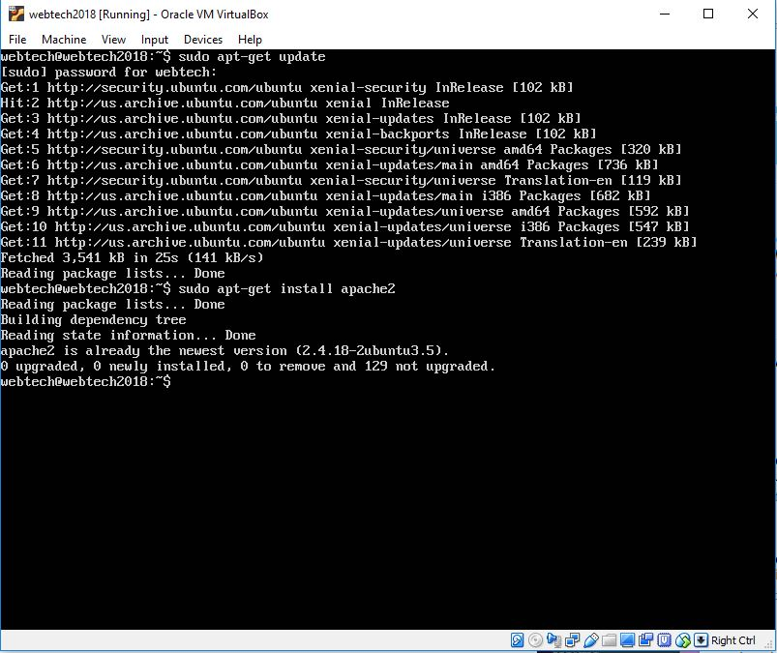

1. Type ifconfig this will show you the network interfaces. The inet address is what you are going to enter in your web browser in the host machine in order to access the default page of Apache2 Ubuntu.

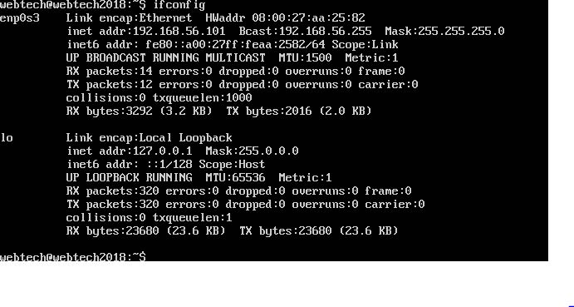

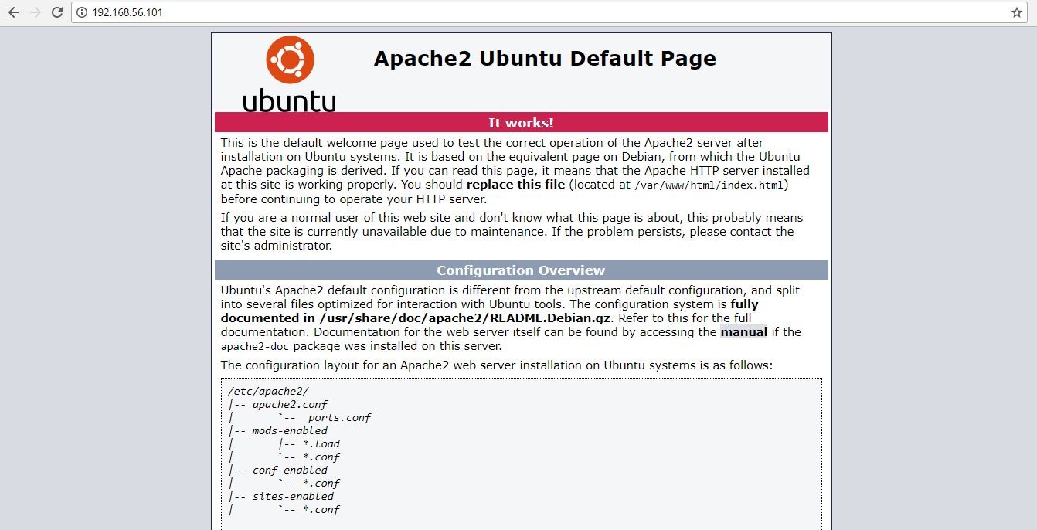

1. Configure the network interface by typing the command,

**sudo nano /etc/network/interfaces**.

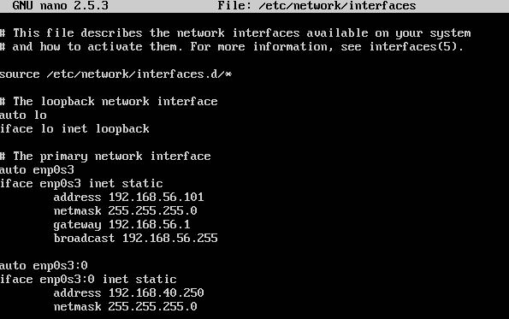

1. In the created directory, create a folder named group6a, group6b and group6c. All files for each site will be saved inside this folder. Once the folder is created ­the user will be prompted to enter a password. Press enter key.

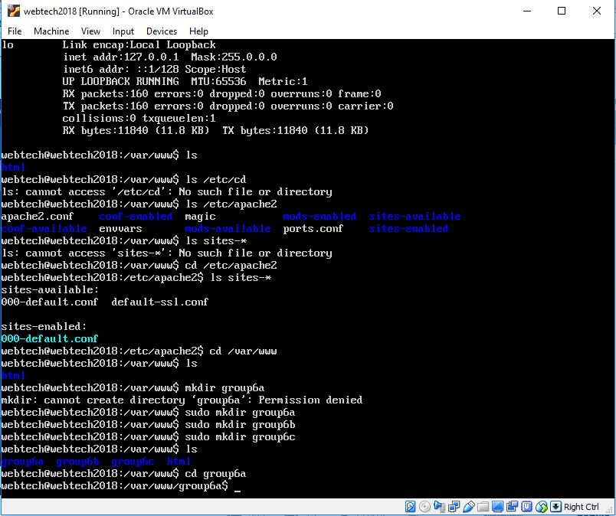

1. Go to each of the created folders and the contents will be the html and css files. To edit a file use sudo nano index.html.



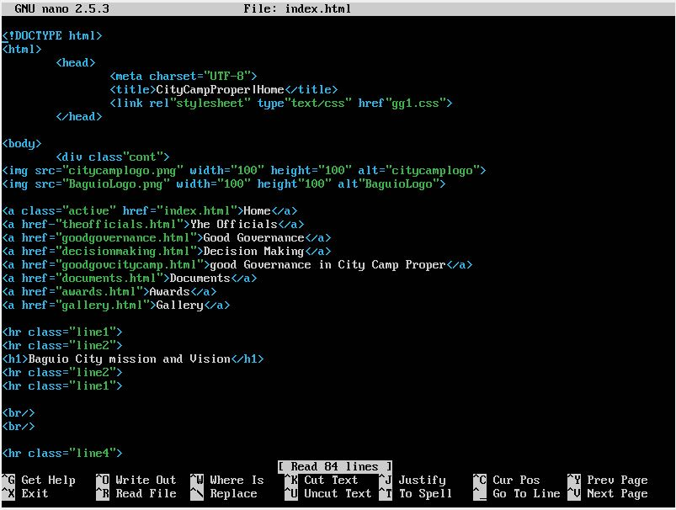

1. Next step is to modify the apache2 configuration, type the command, **cd /etc/apache2** inside this are two folders named **sites-available** and **sites-enabled**. Go to sites available and type **sudo nano default.conf** and configure the domain names, [www.group6a.org](http://www.group6a.org), [www.group6a.org](http://www.group6a.org), [www.group6a.org](http://www.group6a.org) and write the server name, server alias and the document root which refer to the folder that was created in step number 4. Type ctrl + x and press y to save and exit.

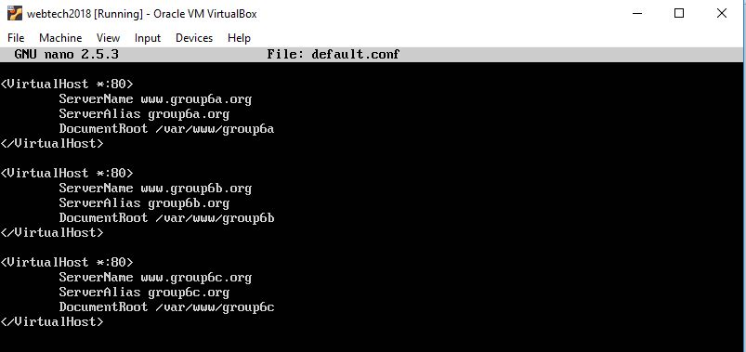

1. To enable default.conf type, **sudo a2ensite default.conf**
2. And disable the 000-default.conf by typing, **sudo a2dissite 000-default.conf**
3. Inside the host machine add the ip address and the domain names inside

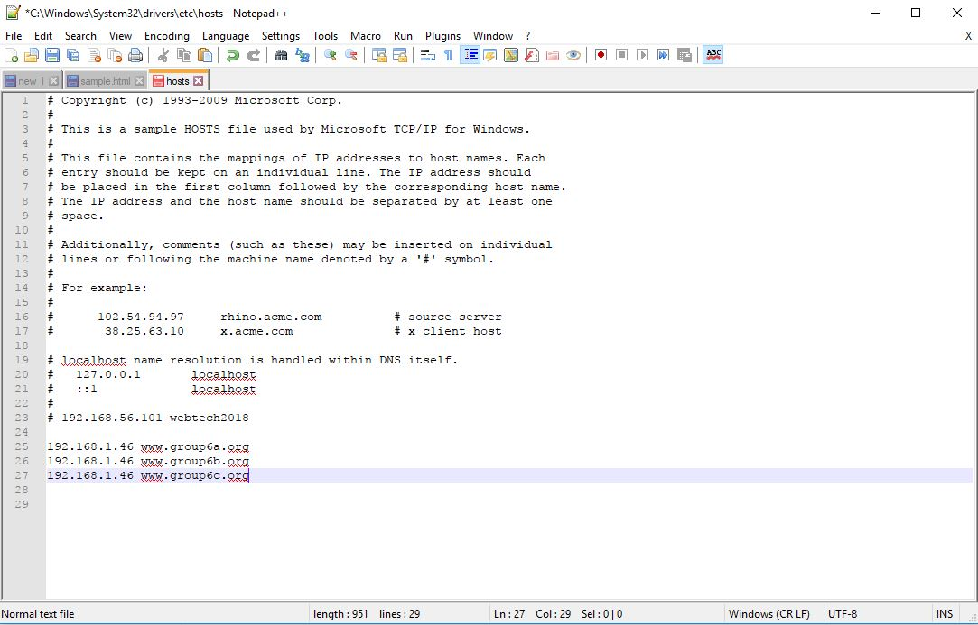

1. Type the ip address or domain name in a web browser on your local machine and it will show you the html file that was saved inside group6a folder, for example.

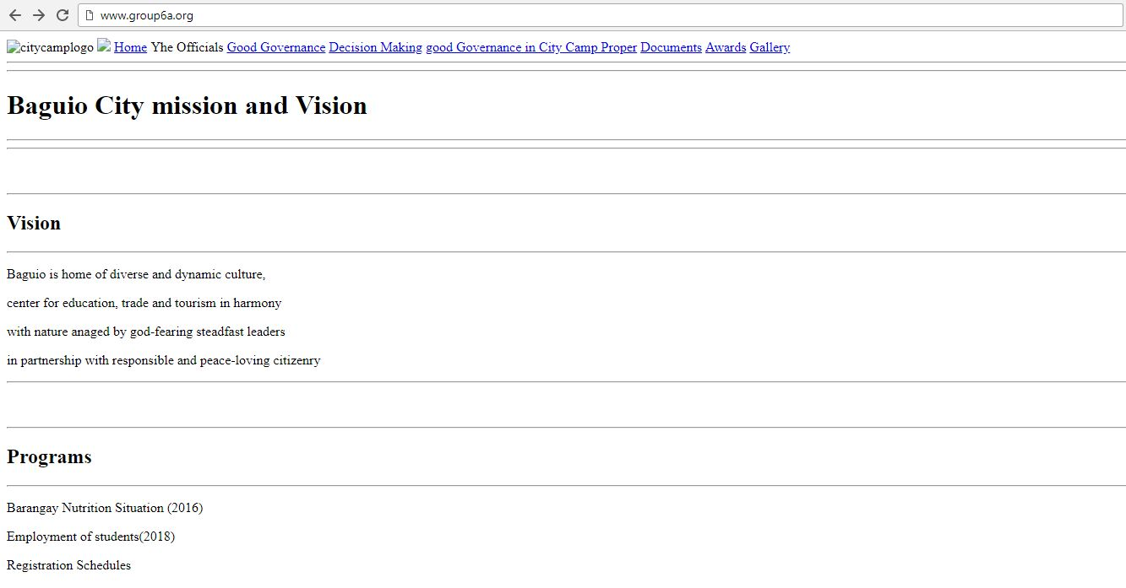

**VIRTUAL HOST CONFIGURATION: ENABLING COMPRESSION OF THE CONTENT**

1. Nsdfgklnf
2. Sdfgnsdfngd
3. Kjsgjnfdskgndkl
4. Sbfgnfsdjgnklds
5. Sbgdskgnkjfsgn